Heptagonal Bipyramid

Definition
# Source: AI Source: Provided by: [Data Path: Persons Table -> ID Column: 1, Name_En Column: Motasem Essam] -> From: [ChatGPT] on [7/25/2026]
A Heptagonal Bipyramid is a three-dimensional polyhedron formed by joining two heptagonal pyramids at their congruent heptagonal bases. The shared heptagonal base becomes an internal face, while the triangular lateral faces form the exterior surface.
It consists of:
- Two apexes positioned on opposite sides of a common heptagonal base.
- Seven vertices forming the shared heptagonal base.
- Fourteen external triangular faces.
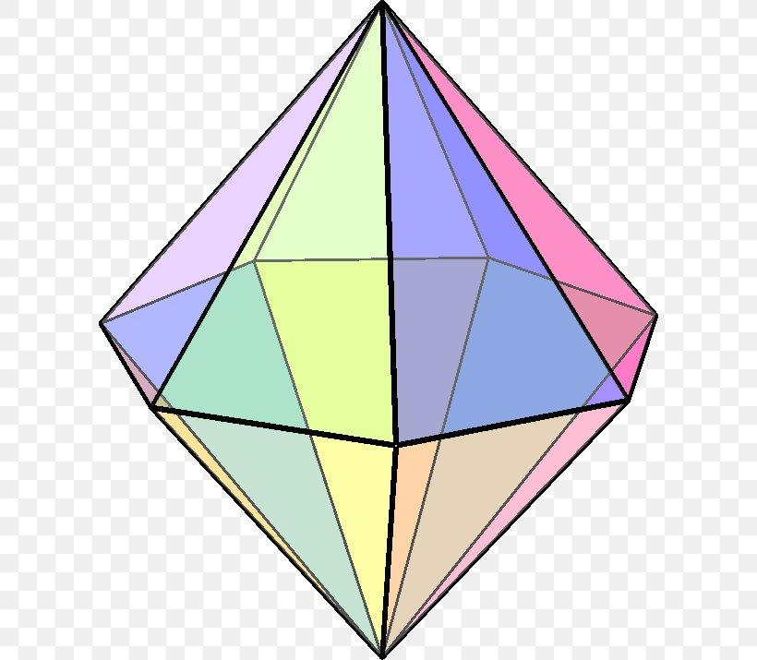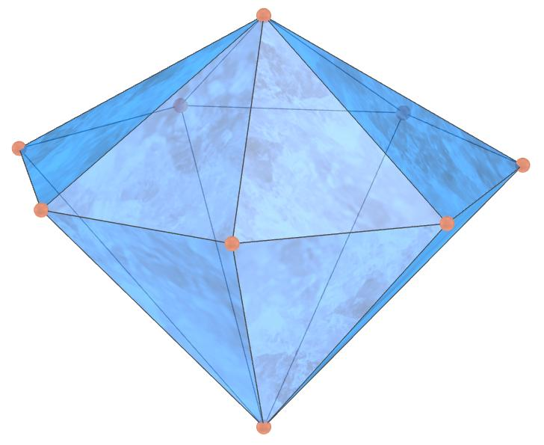

Simple Definition
# Source: AI Source: Provided by: [Data Path: Persons Table -> ID Column: 1, Name_En Column: Motasem Essam] -> From: [ChatGPT] on [7/25/2026]
A heptagonal bipyramid is a solid made by joining two heptagonal pyramids base-to-base, creating a polyhedron with 14 triangular faces, 21 edges, and 9 vertices.

Geometric Structure
# Source: AI Source: Provided by: [Data Path: Persons Table -> ID Column: 1, Name_En Column: Motasem Essam] -> From: [ChatGPT] on [7/25/2026]
The heptagonal bipyramid has three main structural components:
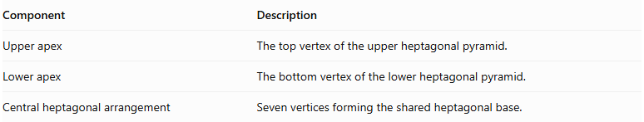
Component | Description
Upper apex | The top vertex of the upper heptagonal pyramid.
Lower apex | The bottom vertex of the lower heptagonal pyramid.
Central heptagonal arrangement | Seven vertices forming the shared heptagonal base.
Both apexes are connected to all seven vertices of the central heptagon.

Face Structure
# Source: AI Source: Provided by: [Data Path: Persons Table -> ID Column: 1, Name_En Column: Motasem Essam] -> From: [ChatGPT] on [7/25/2026]
A heptagonal bipyramid has 14 external triangular faces.
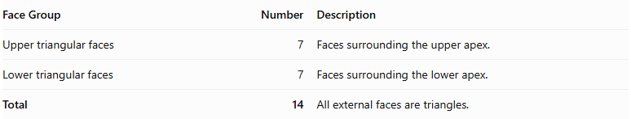
Face Group | Number | Description
Upper triangular faces | 7 | Faces surrounding the upper apex.
Lower triangular faces | 7 | Faces surrounding the lower apex.
Total | 14 | All external faces are triangles.
The common heptagonal base is internal, so it is not counted as an external face.

Edge Structure
# Source: AI Source: Provided by: [Data Path: Persons Table -> ID Column: 1, Name_En Column: Motasem Essam] -> From: [ChatGPT] on [7/25/2026]
The solid has 21 edges, divided into three groups:
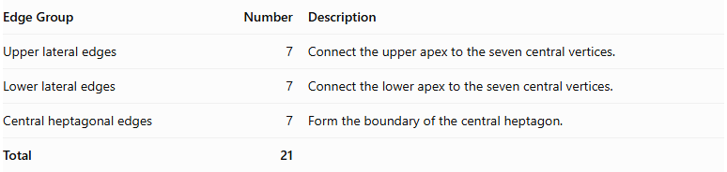
Edge Group | Number | Description
Upper lateral edges | 7 | Connect the upper apex to the seven central vertices.
Lower lateral edges | 7 | Connect the lower apex to the seven central vertices.
Central heptagonal edges | 7 | Form the boundary of the central heptagon.
Total | 21

Vertex Structure
# Source: AI Source: Provided by: [Data Path: Persons Table -> ID Column: 1, Name_En Column: Motasem Essam] -> From: [ChatGPT] on [7/25/2026]
A heptagonal bipyramid has 9 vertices.
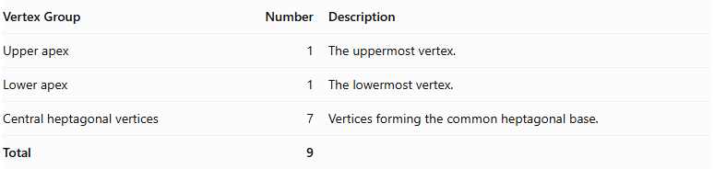
Vertex Group | Number | Description
Upper apex | 1 | The uppermost vertex.
Lower apex | 1 | The lowermost vertex.
Central heptagonal vertices | 7 | Vertices forming the common heptagonal base.
Total | 9

Mathematical Properties
# Source: AI Source: Provided by: [Data Path: Persons Table -> ID Column: 1, Name_En Column: Motasem Essam] -> From: [ChatGPT] on [7/25/2026]
For a heptagonal bipyramid:
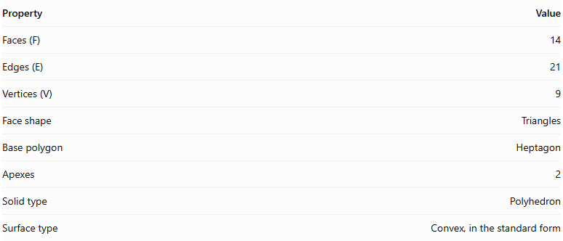
Property | Value
Faces (F) | 14
Edges (E) | 21
Vertices (V) | 9
Face shape | Triangles
Base polygon | Heptagon
Apexes | 2
Solid type | Polyhedron
Surface type | Convex, in the standard form
It satisfies Euler's polyhedron formula:
$$V-E+F=2$$
$$9-21+14=2$$

Face Incidence
# Source: AI Source: Provided by: [Data Path: Persons Table -> ID Column: 1, Name_En Column: Motasem Essam] -> From: [ChatGPT] on [7/25/2026]
In the standard heptagonal bipyramid:
- Each apex is shared by 7 triangular faces.
- Each central heptagonal vertex is shared by 4 triangular faces.

Surface Area and Volume

Surface Area
# Source: AI Source: Provided by: [Data Path: Persons Table -> ID Column: 1, Name_En Column: Motasem Essam] -> From: [ChatGPT] on [7/25/2026]
The total surface area is the sum of the areas of the fourteen external triangular faces.
$$SA=7A_{u}+7A_{l}$$
Where:
- $A_{u}$ = area of one upper triangular face.
- $A_{l}$ = area of one lower triangular face.
If the upper and lower pyramids are congruent:
$$SA=14A_{t}$$
For a regular heptagonal bipyramid with identical triangular faces, where each triangle has base side length $s$ and slant height $l$:
$$SA=14(\frac{1}{2}sl)$$
$$\boxed{SA=7sl}$$

Volume
# Source: AI Source: Provided by: [Data Path: Persons Table -> ID Column: 1, Name_En Column: Motasem Essam] -> From: [ChatGPT] on [7/25/2026]
The volume is the sum of the volumes of the two heptagonal pyramids.
$$V=\frac{1}{3}{Bh}_{u}+\frac{1}{3}{Bh}_{l}$$
Therefore:
$$\boxed{V=\frac{1}{3}B(h_{u}+h_{l})}$$
Where:
- $B$ = area of the common heptagonal base.
- $h_{u}$ = height of the upper pyramid.
- $h_{l}$ = height of the lower pyramid.
For a regular heptagonal base with side length $s$:
$$B=\frac{7s^{2}}{4tan(π/7)}$$
Therefore:
$$\boxed{V=\frac{7s^{2}}{12tan(π/7)}(h_{u}+h_{l})}$$

Symmetry
# Source: AI Source: Provided by: [Data Path: Persons Table -> ID Column: 1, Name_En Column: Motasem Essam] -> From: [ChatGPT] on [7/25/2026]
A regular heptagonal bipyramid with congruent upper and lower pyramids has the following symmetries:
- Sevenfold rotational symmetry: Rotation by approximately ${51.43}^{∘}$ around the central axis maps the solid onto itself.
- Vertical reflection planes: Seven planes pass through the central axis and the central heptagonal arrangement.
- Horizontal reflection plane: The central heptagonal plane reflects the upper half onto the lower half.
- Central inversion symmetry: Each point has a corresponding opposite point through the solid's center.

Relationship to Other Solids
# Source: AI Source: Provided by: [Data Path: Persons Table -> ID Column: 1, Name_En Column: Motasem Essam] -> From: [ChatGPT] on [7/25/2026]
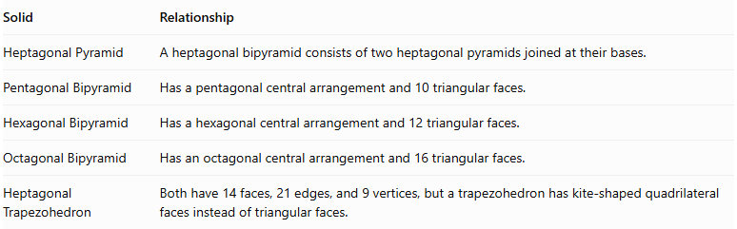
Solid | Relationship
Heptagonal Pyramid | A heptagonal bipyramid consists of two heptagonal pyramids joined at their bases.
Pentagonal Bipyramid | Has a pentagonal central arrangement and 10 triangular faces.
Hexagonal Bipyramid | Has a hexagonal central arrangement and 12 triangular faces.
Octagonal Bipyramid | Has an octagonal central arrangement and 16 triangular faces.
Heptagonal Trapezohedron | Both have 14 faces, 21 edges, and 9 vertices, but a trapezohedron has kite-shaped quadrilateral faces instead of triangular faces.

Worked Examples

Example 1: Calculate the Number of Faces, Edges, and Vertices
# Source: AI Source: Provided by: [Data Path: Persons Table -> ID Column: 1, Name_En Column: Motasem Essam] -> From: [ChatGPT] on [7/25/2026]
Given: A heptagonal bipyramid has a heptagonal central arrangement.
For an $n$-gonal bipyramid:
$$F=2n, E=3n, V=n+2$$
Since $n=7$:
$$F=2(7)=14$$
$$E=3(7)=21$$
$$V=7+2=9$$
Answer:
- Faces = 14
- Edges = 21
- Vertices = 9

Example 2: Calculate the Volume
# Source: AI Source: Provided by: [Data Path: Persons Table -> ID Column: 1, Name_En Column: Motasem Essam] -> From: [ChatGPT] on [7/25/2026]
Given:
- Area of the heptagonal base: $B=84{ cm}^{2}$
- Upper pyramid height: $h_{u}=12 cm$
- Lower pyramid height: $h_{l}=9 cm$
Using:
$$V=\frac{1}{3}B(h_{u}+h_{l})$$
Substitute:
$$V=\frac{1}{3}(84)(12+9)$$
$$V=\frac{1764}{3}$$
$$\boxed{V=588{ cm}^{3}}$$

Constructing Heptagonal Bipyramid in Solid Geometry

Geometric Instruments Used
# Source: AI Source: Provided by: [Data Path: Persons Table -> ID Column: 1, Name_En Column: Motasem Essam] -> From: [ChatGPT] on [7/25/2026]
The construction uses traditional geometric instruments rather than coordinate-based construction.
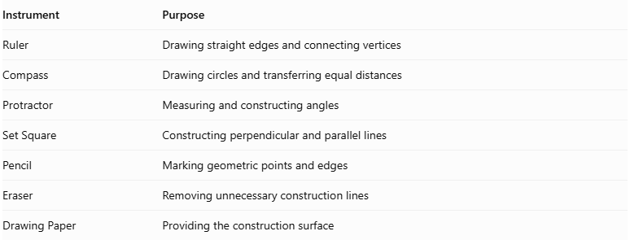
Instrument | Purpose
Ruler | Drawing straight edges and connecting vertices
Compass | Drawing circles and transferring equal distances
Protractor | Measuring and constructing angles
Set Square | Constructing perpendicular and parallel lines
Pencil | Marking geometric points and edges
Eraser | Removing unnecessary construction lines
Drawing Paper | Providing the construction surface

Instrument-Based Construction Procedures

Constructing the Heptagonal Base
# Source: AI Source: Provided by: [Data Path: Persons Table -> ID Column: 1, Name_En Column: Motasem Essam] -> From: [ChatGPT] on [7/25/2026]
- Draw a circle using a compass.
- Mark the center of the circle.
- Divide the circle into seven equal angular sections using a protractor.
- Each central angle measures approximately:
$$\frac{{360}^{∘}}{7}≈{51.4286}^{∘}$$
- Mark the seven points around the circumference.
- Connect consecutive points using a ruler.
- Complete the regular heptagonal base.

Constructing the First Pyramid
# Source: AI Source: Provided by: [Data Path: Persons Table -> ID Column: 1, Name_En Column: Motasem Essam] -> From: [ChatGPT] on [7/25/2026]
- Identify the center of the heptagonal base.
- Construct a perpendicular line passing through the center of the base.
- Mark the first apex above the base plane.
- Connect the apex to all seven vertices of the heptagon.
- Form seven triangular lateral faces.

Constructing the Second Pyramid
# Source: AI Source: Provided by: [Data Path: Persons Table -> ID Column: 1, Name_En Column: Motasem Essam] -> From: [ChatGPT] on [7/25/2026]
- Extend the perpendicular axis through the base plane in the opposite direction.
- Mark the second apex below the base plane.
- Connect the second apex to all seven vertices of the heptagon.
- Form another seven triangular lateral faces.

Completing the Bipyramid
# Source: AI Source: Provided by: [Data Path: Persons Table -> ID Column: 1, Name_En Column: Motasem Essam] -> From: [ChatGPT] on [7/25/2026]
- Check that both pyramids share the same heptagonal base.
- Ensure that the two apices are on opposite sides of the base plane.
- Darken the visible external edges.
- Represent hidden edges using dashed lines when necessary.
- Remove unnecessary construction marks.

Key Points
# Source: AI Source: Provided by: [Data Path: Persons Table -> ID Column: 1, Name_En Column: Motasem Essam] -> From: [ChatGPT] on [7/25/2026]
- A heptagonal bipyramid is formed by joining two heptagonal pyramids at their bases.
- It has 14 external triangular faces.
- It has 21 edges.
- It has 9 vertices.
- Its common heptagonal base is internal and is not counted as an external face.
- Its volume is the sum of the volumes of the two heptagonal pyramids.
- A regular symmetric heptagonal bipyramid has sevenfold rotational symmetry.

Conclusion
# Source: AI Source: Provided by: [Data Path: Persons Table -> ID Column: 1, Name_En Column: Motasem Essam] -> From: [ChatGPT] on [7/25/2026]
The Heptagonal Bipyramid is a polyhedron formed by combining two heptagonal pyramids around a shared heptagonal base. It belongs to the family of $n$-gonal bipyramids and has 14 triangular faces, 21 edges, and 9 vertices.
Its defining characteristic is the seven-sided central arrangement connecting the upper and lower apexes.

